34/52 as the score

**CS 4328: Homework #1**

Due on Feb, 14, 2019

Jamal Rasool









**Problem 5**

1. Top w/ appropriate arguments
   1. top -o %MEM

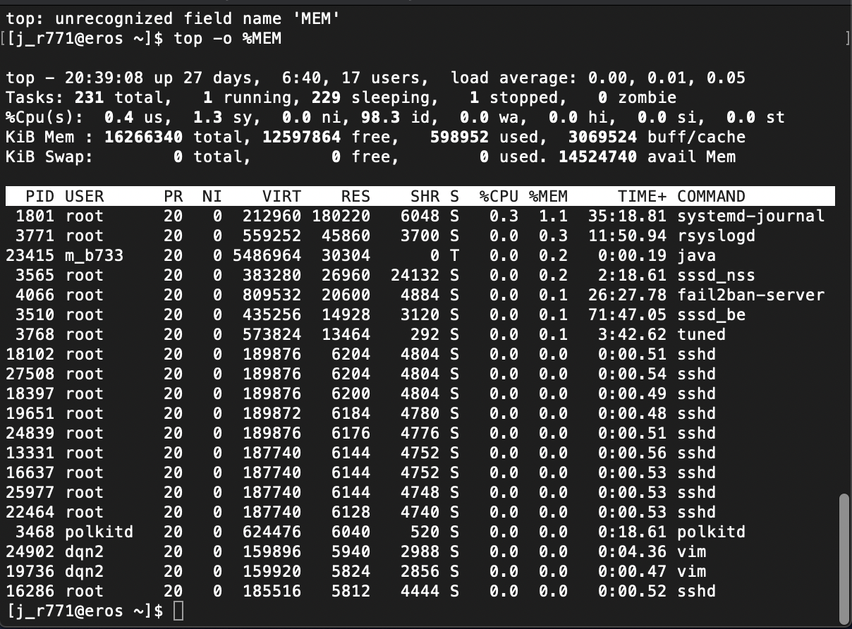

1. Pstree w/ appropriate arguments
   1. pstree -p -s 1

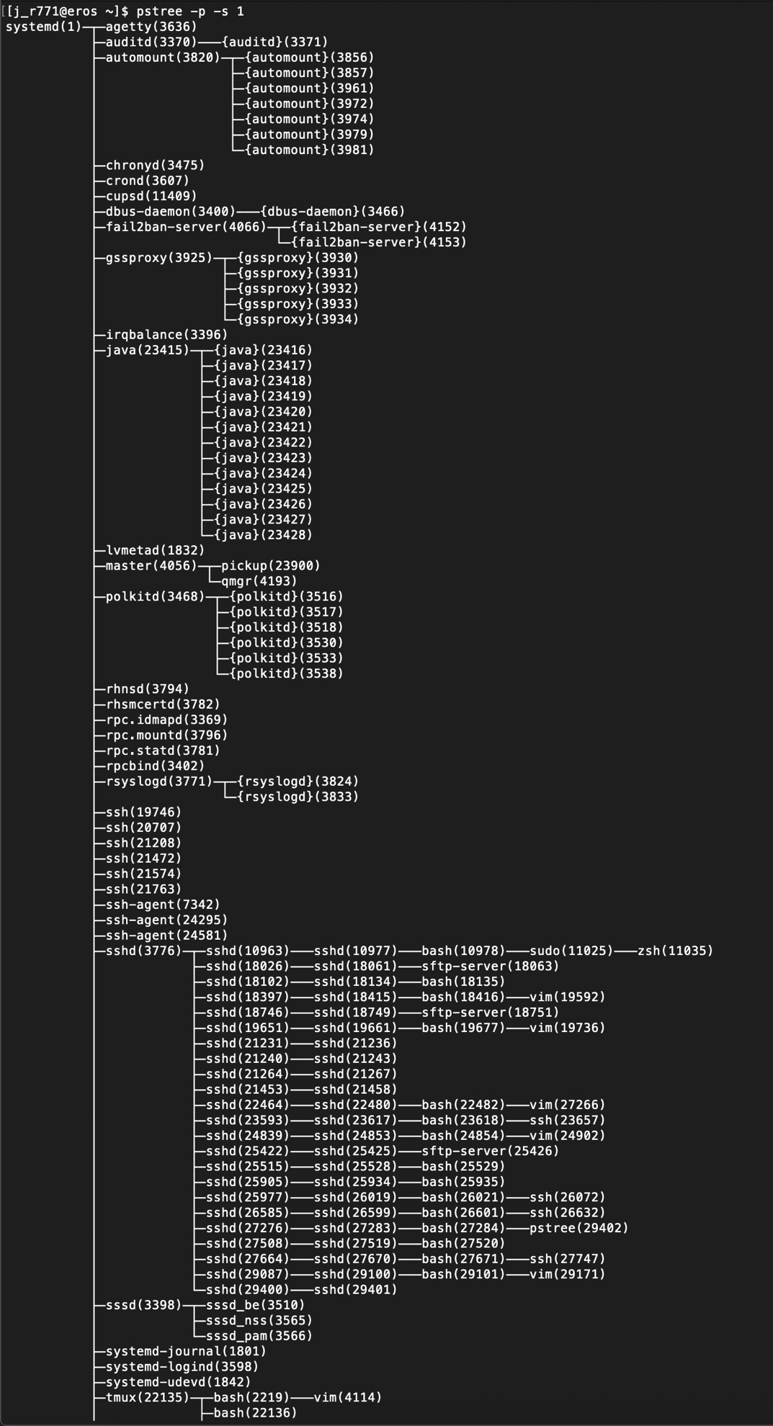

1. Ps w/ appropritate arguments
   1. ps aux | grep root | wc -l

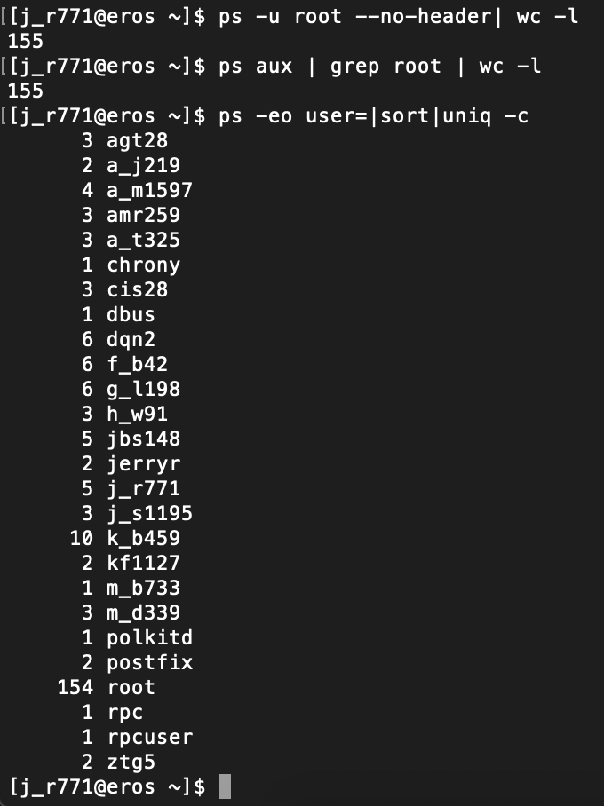

1. Server uptime
   1. uptime -p (Server is up for 3 weeks, 6 days, 7 hours, 17 minutes)

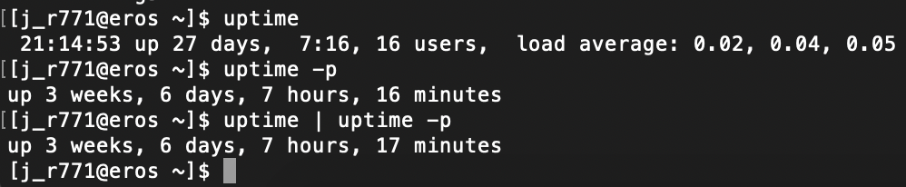

**Problem 6**

A zombie process can best be defined as when a parent process isn’t programmed properly and never calls the respective wait() function call, the zombie children that it will generate will stick around in memory until it’s cleaned up. More or less a zombie process is basically the left over bits of dead processes that have not been cleaned up properly.

Program that uses fork() goes as follows:

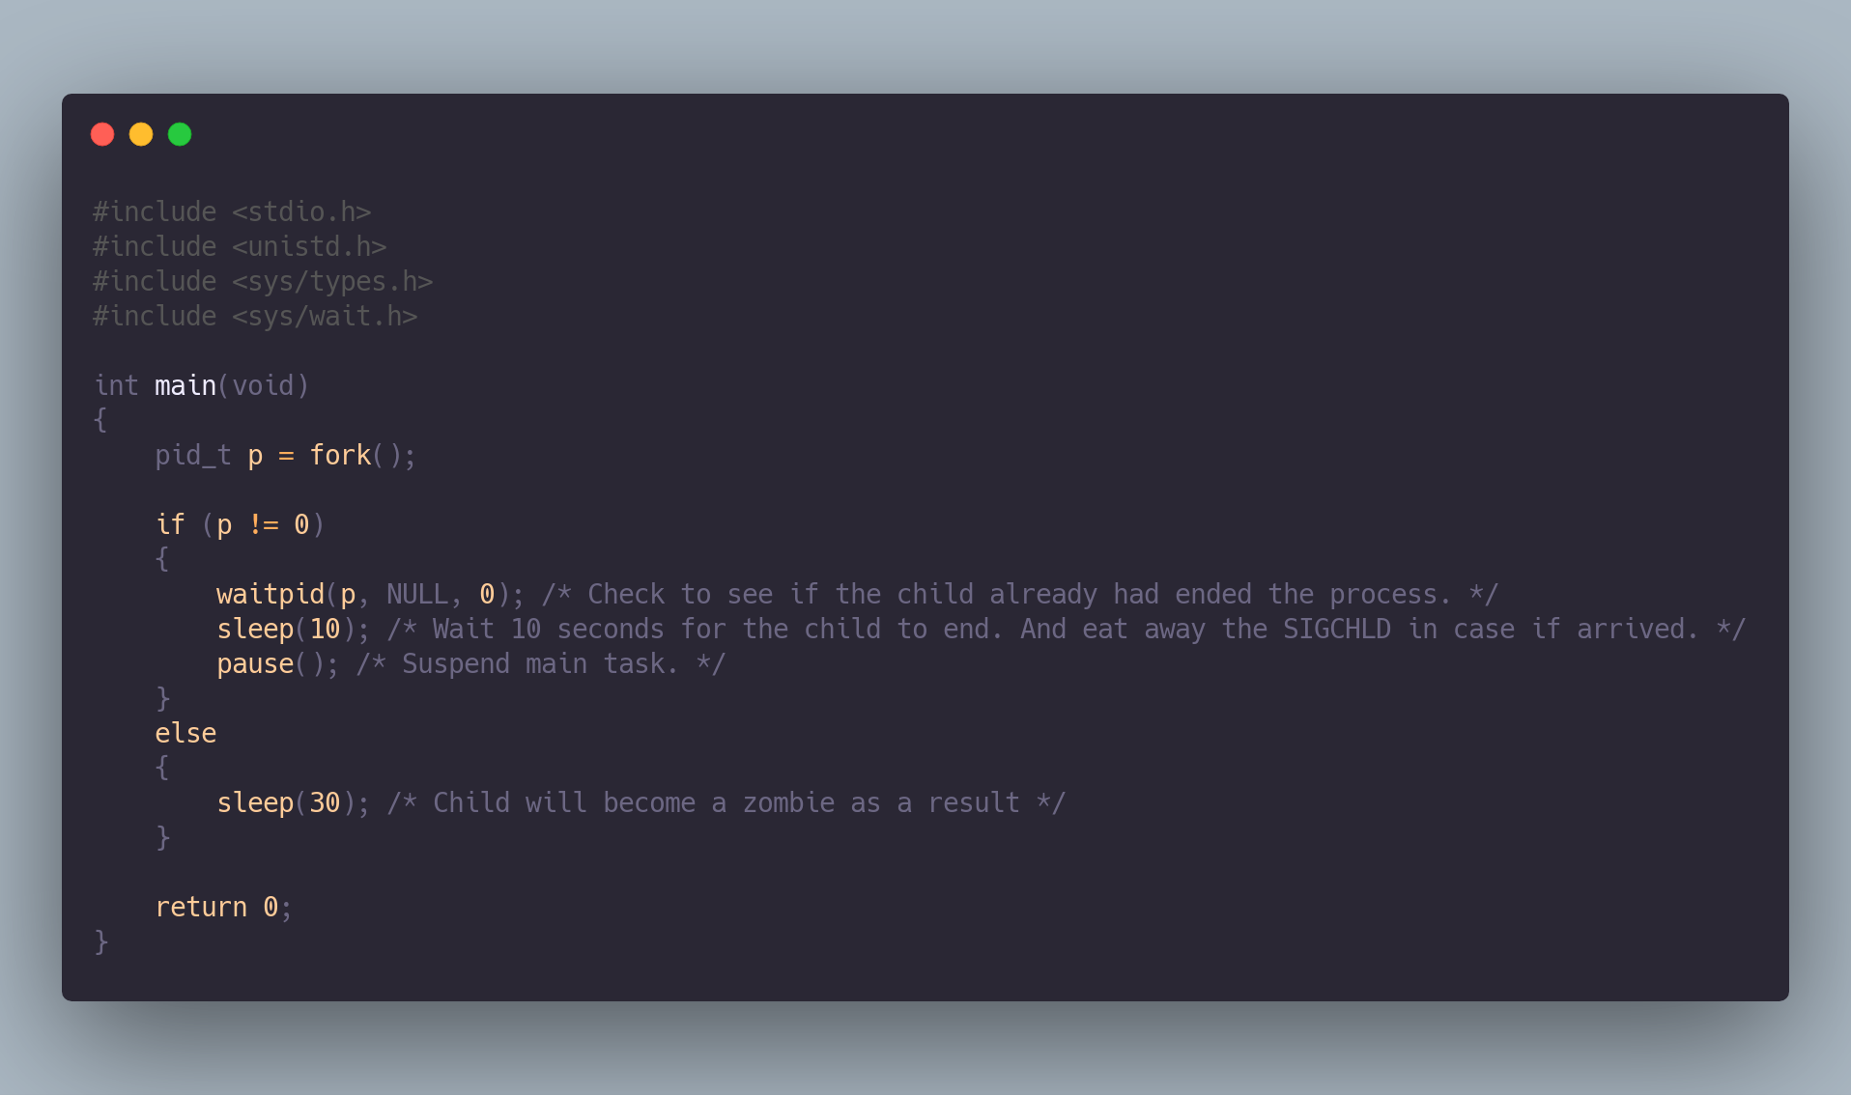

To remove the following zombie process one could run the following Linux command in order to stop the execution and remove the zombie process “kill -s SIGCHLD pid” to remove the child process ID.